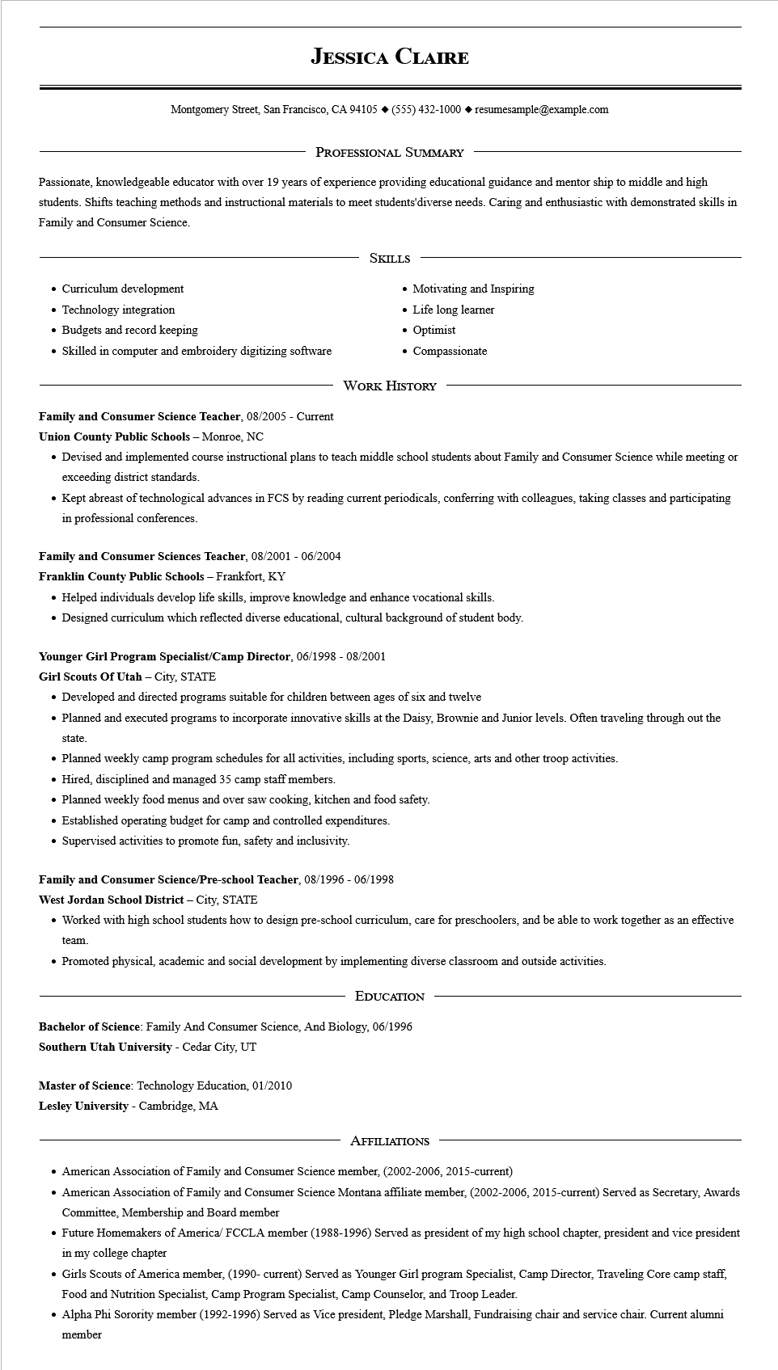
JESSICA CLAIRE
Montgomery Street, San Francisco, CA 94105 ◆ (555) 432-1000 resumesample@example.com
PROFESSIONAL SUMMARY
Passionate, knowledgeable educator with over 19 years of experience providing educational guidance and mentor ship to middle and high students. Shifts teaching methods and instructional materials to meet students'diverse needs. Caring and enthusiastic with demonstrated skills in Family and Consumer Science.
• Curriculum development
• Technology integration
• Budgets and record keeping
• Skilled in computer and embroidery digitizing software
SKILLS
• Motivating and Inspiring
• Life long learner
• Optimist
• Compassionate
WORK HISTORY
Family and Consumer Science Teacher, 08/2005 - Current
Union County Public Schools - Monroe, NC
• Devised and implemented course instructional plans to teach middle school students about Family and Consumer Science while meeting or exceeding district standards.
• Kept abreast of technological advances in FCS by reading current periodicals, conferring with colleagues, taking classes and participating in professional conferences.
Family and Consumer Sciences Teacher, 08/2001 - 06/2004
Franklin County Public Schools - Frankfort, KY
• Helped individuals develop life skills, improve knowledge and enhance vocational skills.
• Designed curriculum which reflected diverse educational, cultural background of student body.
Younger Girl Program Specialist/Camp Director, 06/1998 - 08/2001
Girl Scouts Of Utah - City, STATE
• Developed and directed programs suitable for children between ages of six and twelve
• Planned and executed programs to incorporate innovative skills at the Daisy, Brownie and Junior levels. Often traveling through out the
state.
• Planned weekly camp program schedules for all activities, including sports, science, arts and other troop activities.
• Hired, disciplined and managed 35 camp staff members.
• Planned weekly food menus and over saw cooking, kitchen and food safety.
• Established operating budget for camp and controlled expenditures.
• Supervised activities to promote fun, safety and inclusivity.
Family and Consumer Science/Pre-school Teacher, 08/1996 - 06/1998
West Jordan School District - City, STATE
• Worked with high school students how to design pre-school curriculum, care for preschoolers, and be able to work together as an effective team.
• Promoted physical, academic and social development by implementing diverse classroom and outside activities.
EDUCATION
Bachelor of Science: Family And Consumer Science, And Biology, 06/1996
Southern Utah University - Cedar City, UT
Master of Science: Technology Education, 01/2010
Lesley University - Cambridge, MA
AFFILIATIONS
• American Association of Family and Consumer Science member, (2002-2006, 2015-current)
• American Association of Family and Consumer Science Montana affiliate member, (2002-2006, 2015-current) Served as Secretary, Awards Committee, Membership and Board member
• Future Homemakers of America/ FCCLA member (1988-1996) Served as president of my high school chapter, president and vice president in my college chapter
• Girls Scouts of America member, (1990- current) Served as Younger Girl program Specialist, Camp Director, Traveling Core camp staff, Food and Nutrition Specialist, Camp Program Specialist, Camp Counselor, and Troop Leader.
• Alpha Phi Sorority member (1992-1996) Served as Vice president, Pledge Marshall, Fundraising chair and service chair. Current alumni member

